CRUSOURCE CRM TEST CASES
- LEADS
- PASS – works
- IMPROVE – Works but need fixes
- FAIL – Not Working
TESTCASES:
No: AICRM-0001
Result: Pass
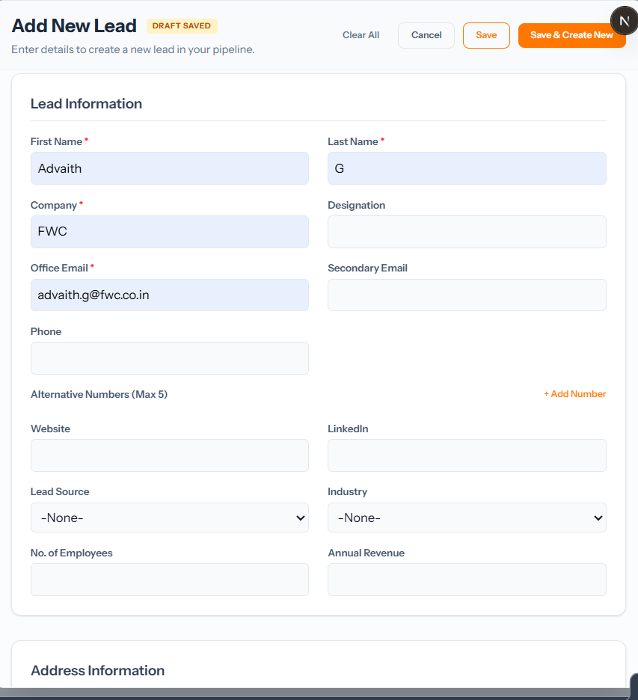
No: AICRM-0002
Result: IMPROVE – Show Error at field (Firstname) where input is not there
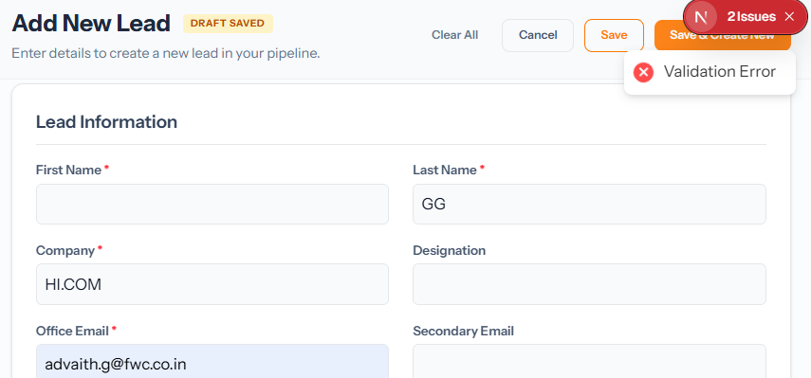

No: AICRM-0003
Result: IMPROVE – Show Error at field (Lastname) where input is not there
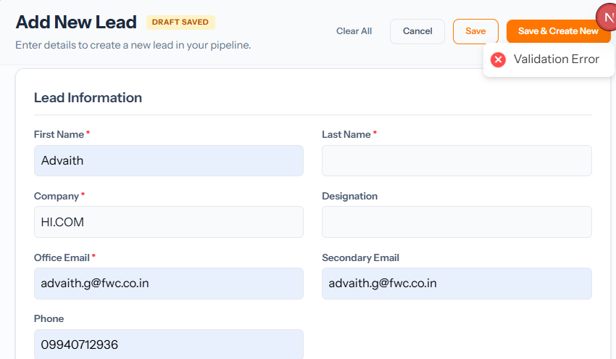
No: AICRM-0004
Result: Pass
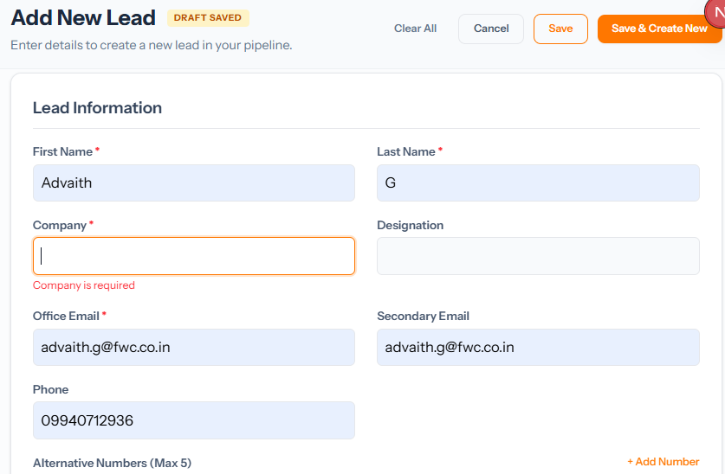
No: AICRM-0005
Result: : IMPROVE – Show Error at field (Office Email) where input is not there
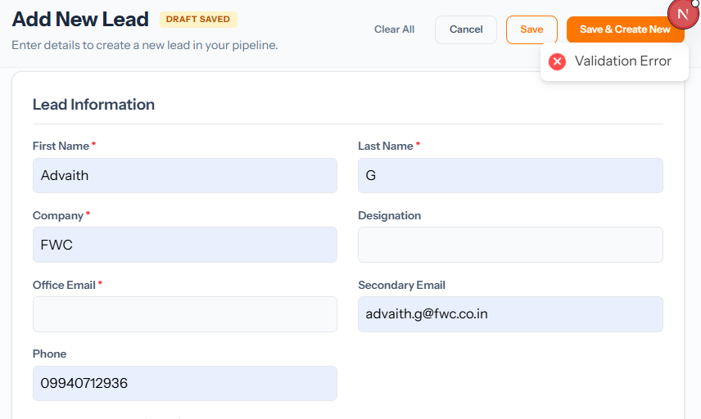
No: AICRM-0006
Result: FAIL – adva@gma.co works and creates a lead
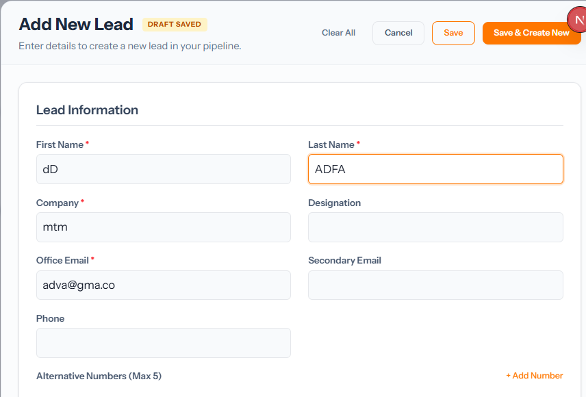
No: AICRM-0007
Result: IMPROVE – AICRM006 Testcase issue
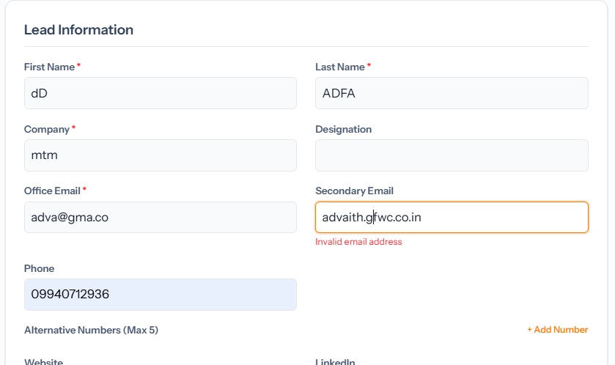
No: AICRM-0008
Result: FAIL – No man number limit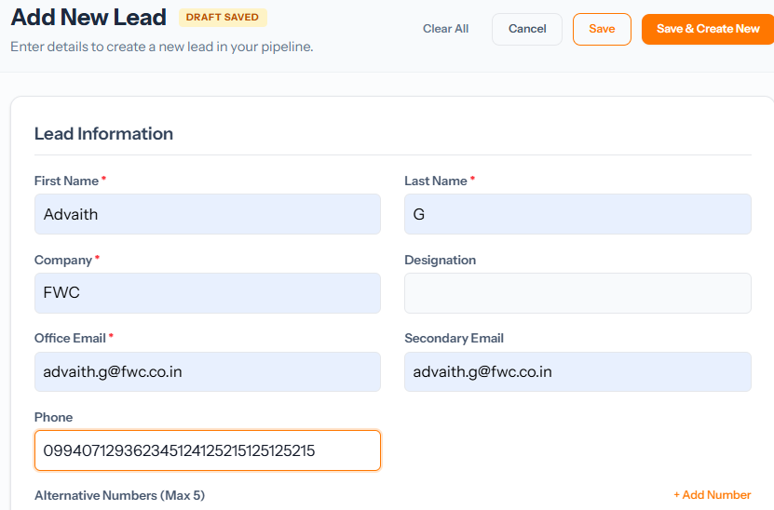
No: AICRM-0009
Result: FAIL – No input validation
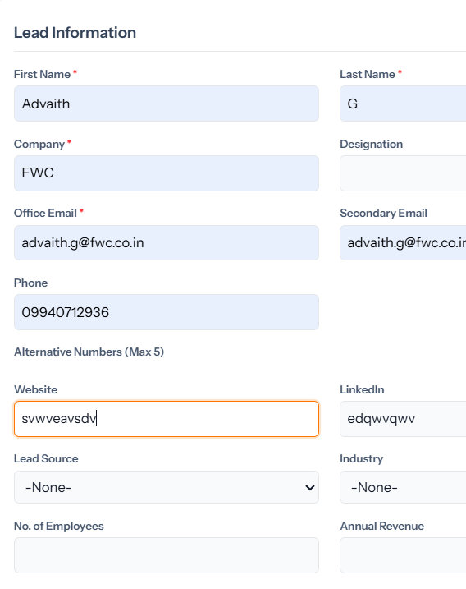
No: AICRM-0010
Result: : FAIL – No input validation
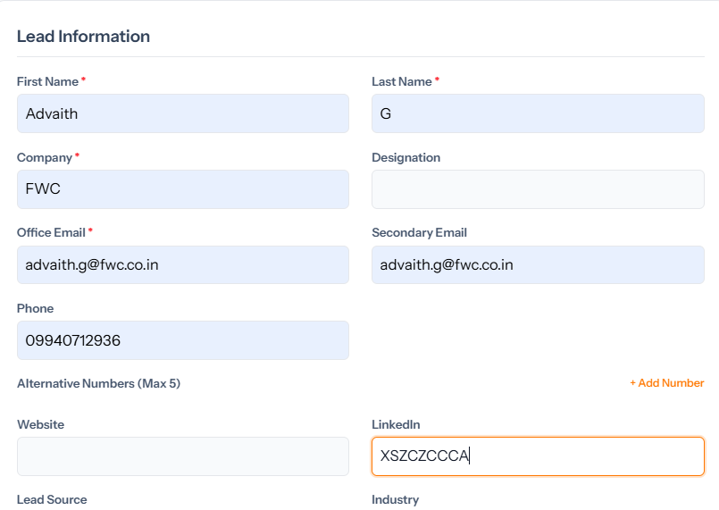
No: AICRM-0011
Result: Pass 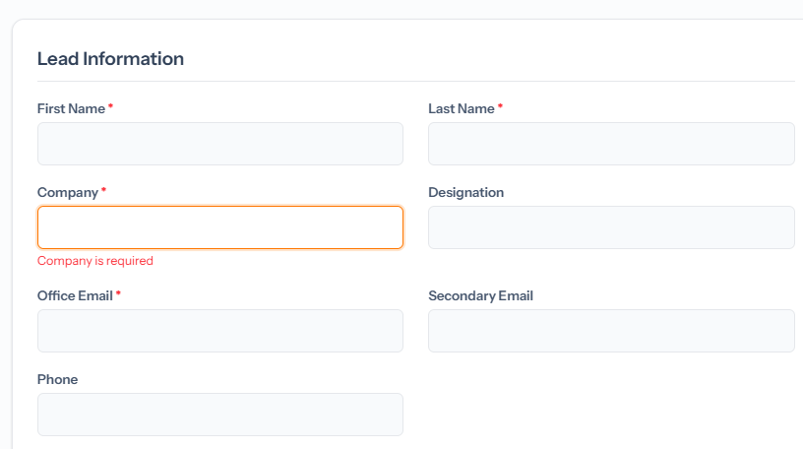
No: AICRM-0012
Result: FAIL – No input validation
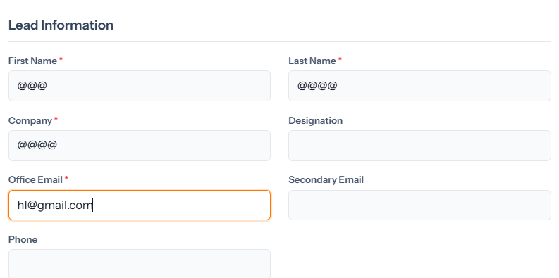
No: AICRM-0013
Result: FAIL – No input validation
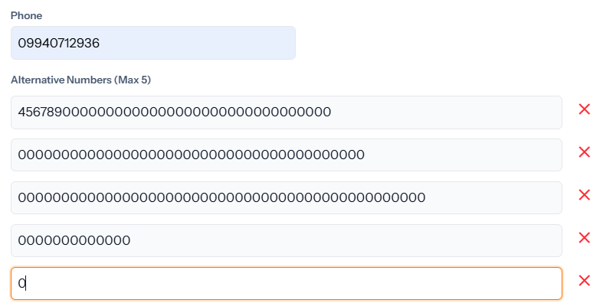
No: AICRM-0014
Result: Pass
No: AICRM-0015
Result: Pass
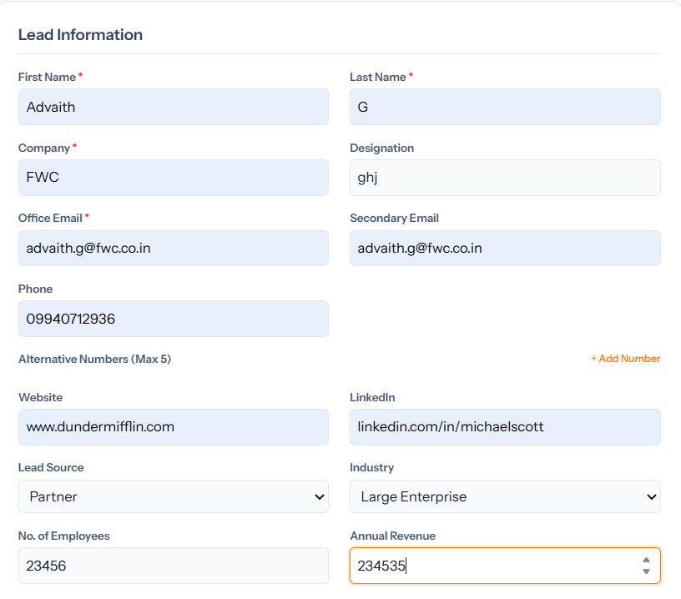
No: AICRM-0016
Result: Pass
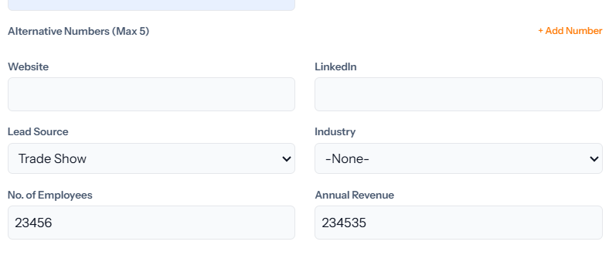
No: AICRM-0017
Result: Pass
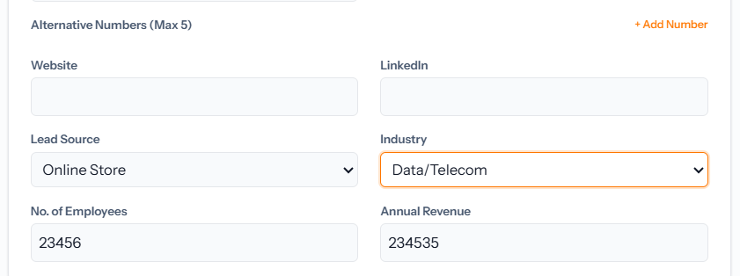
No: AICRM-0018
Result: Pass
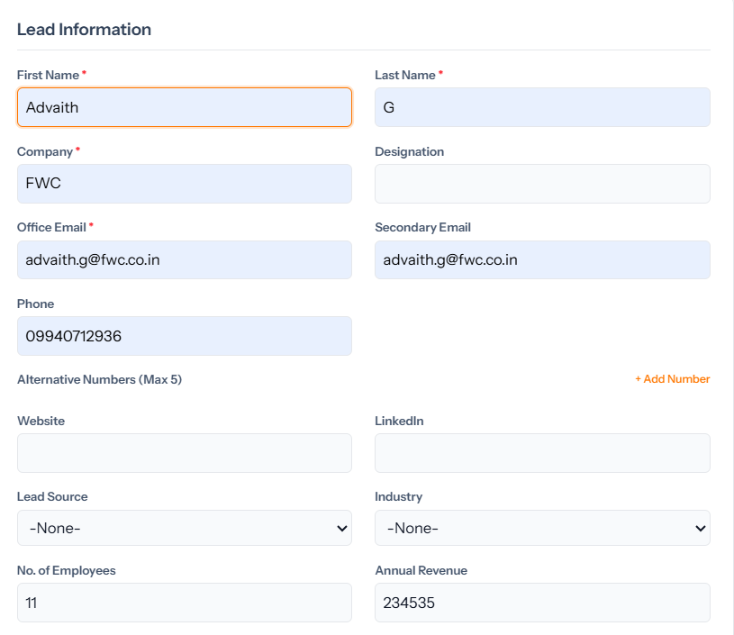
No: AICRM-0019
Result: IMPROVE – No min and max limit for the input

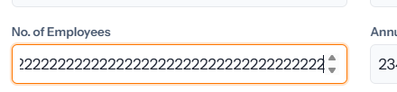
No: AICRM-0020
Result: Pass
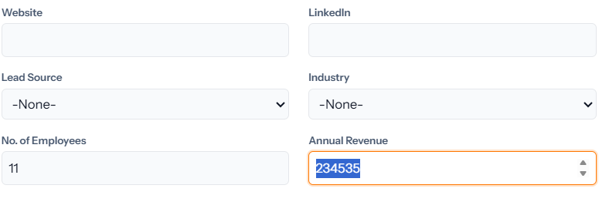
No: AICRM-0021
Result: FAIL – No input validation
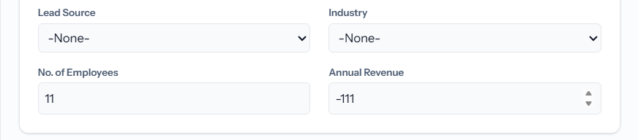
No: AICRM-0022
Result: Pass
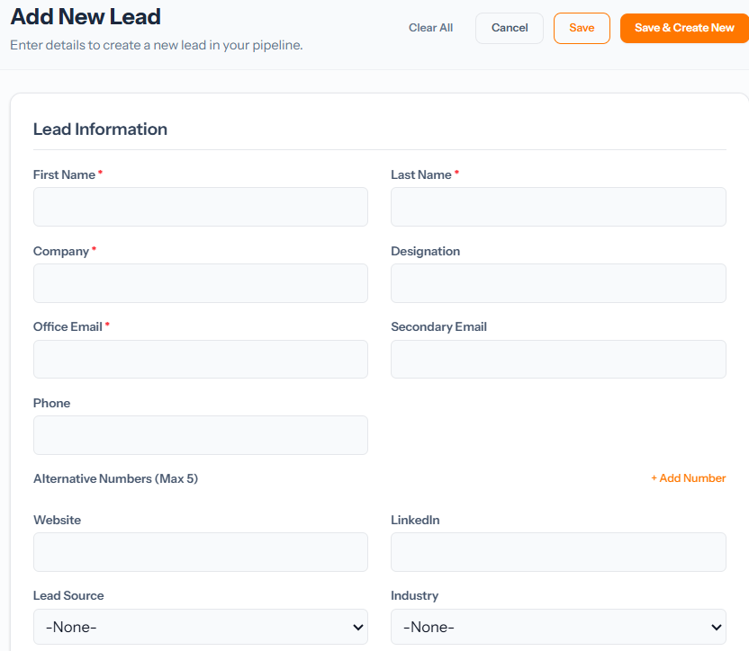
No: AICRM-0023
Result: Pass
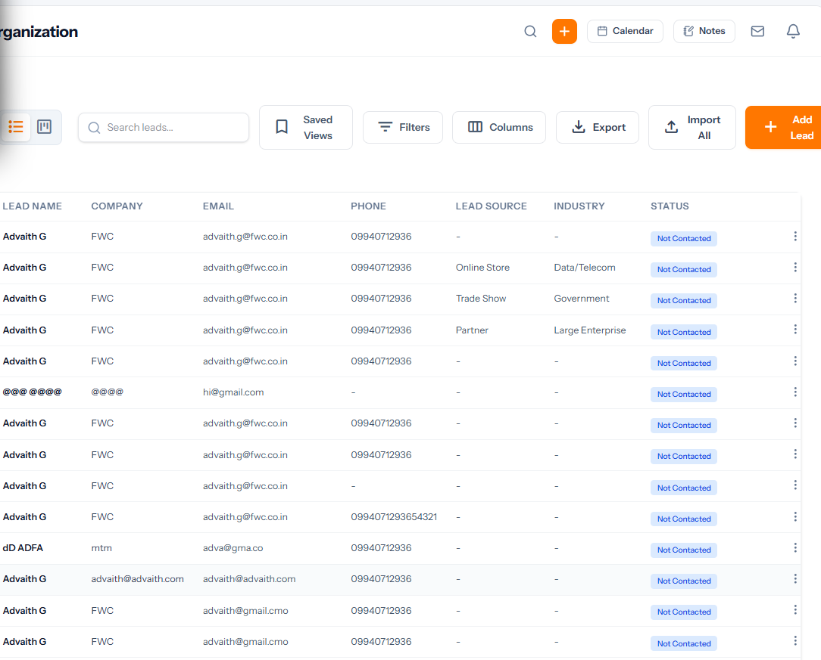
No: AICRM-0024
Result: Pass
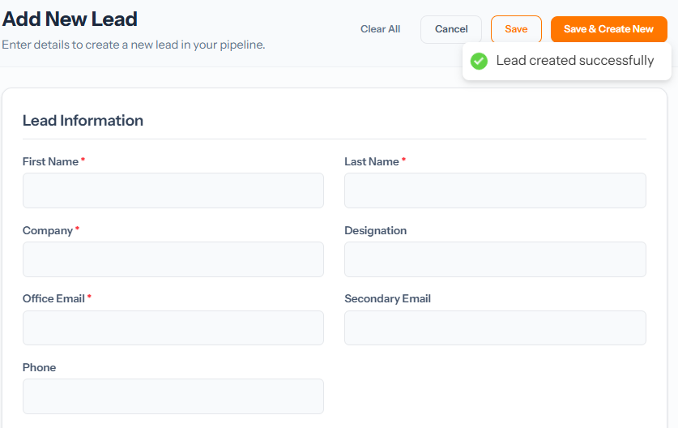
No: AICRM-0025
Result: Pass
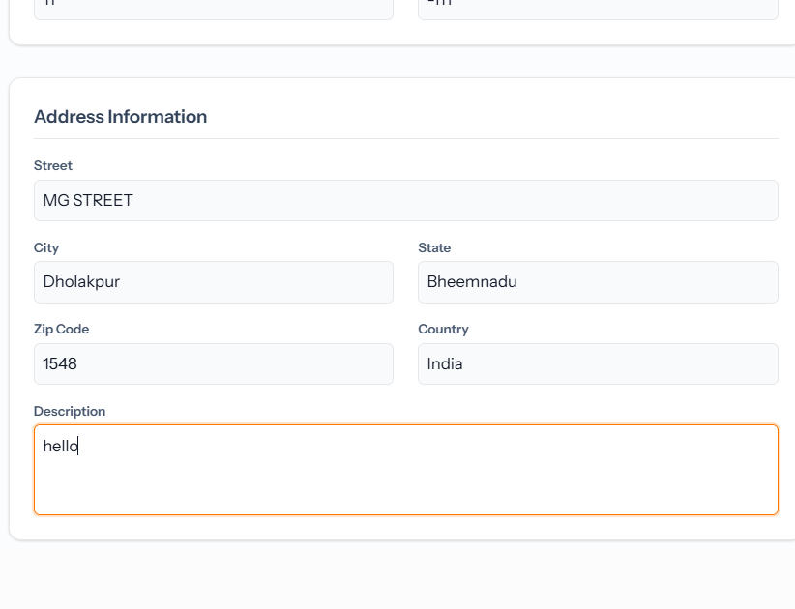
No: AICRM-0026
Result: Pass 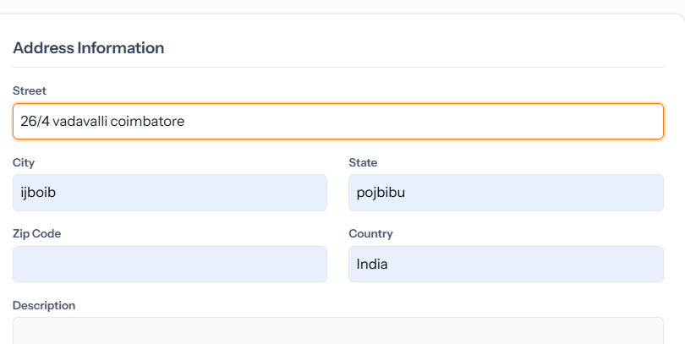
No: AICRM-0027
Result: FAIL – No input validation
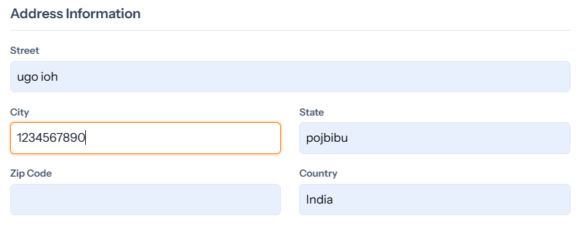
No: AICRM-0028
Result: FAIL – No input validation
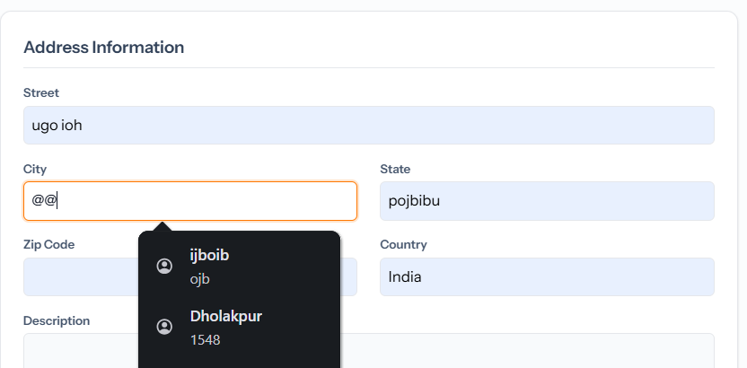
No: AICRM-0029
Result: FAIL – No input validation 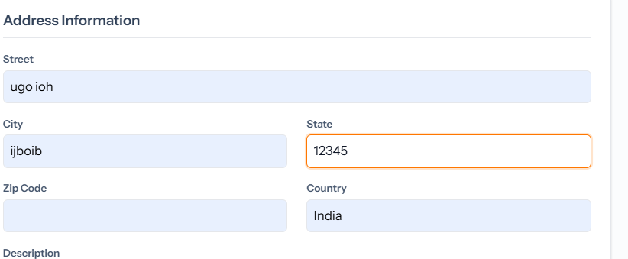
No: AICRM-0030
Result: FAIL – No input validation
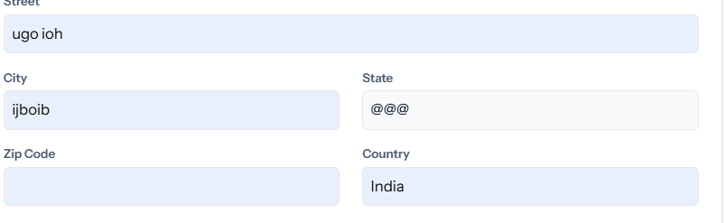
No: AICRM-0031
Result: FAIL – No input validation, Sug: Try to Bring dropdowns
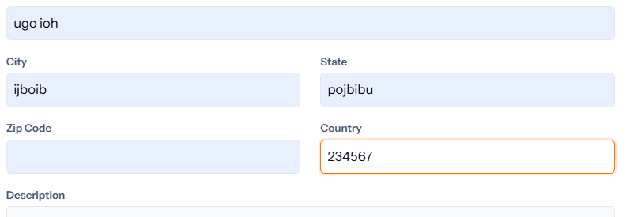
No: AICRM-0032
Result: FAIL – No input validation
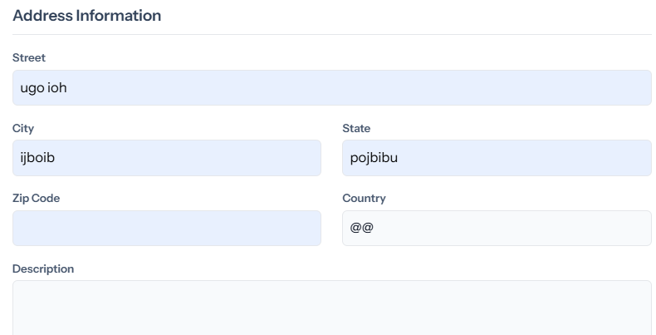
No: AICRM-0033
Result: IMPROVE – Max input limit
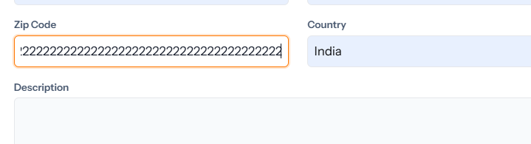
No: AICRM-0034
Result: Pass
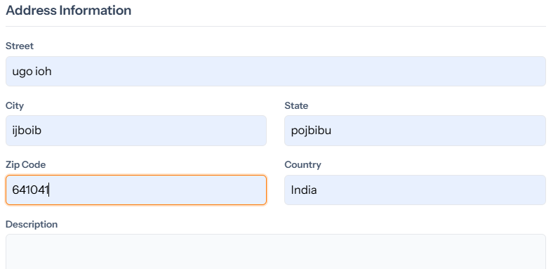
No: AICRM-0035
Result: Test Case not needed
No: AICRM-0036
Result: Pass
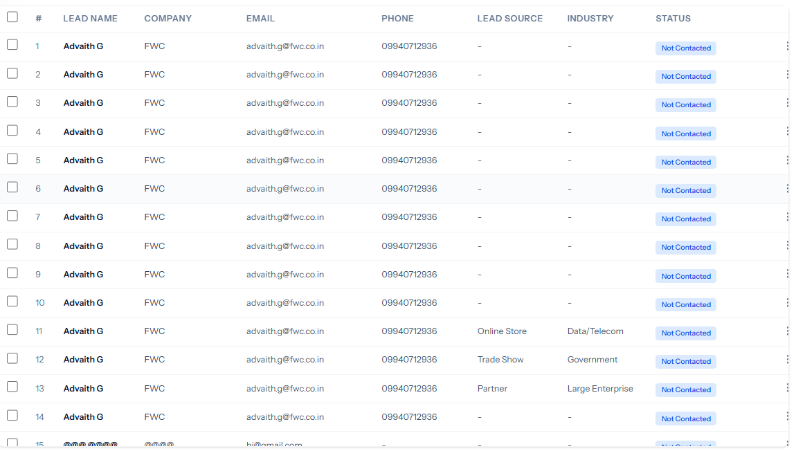
No: AICRM-0037
Result: Pass
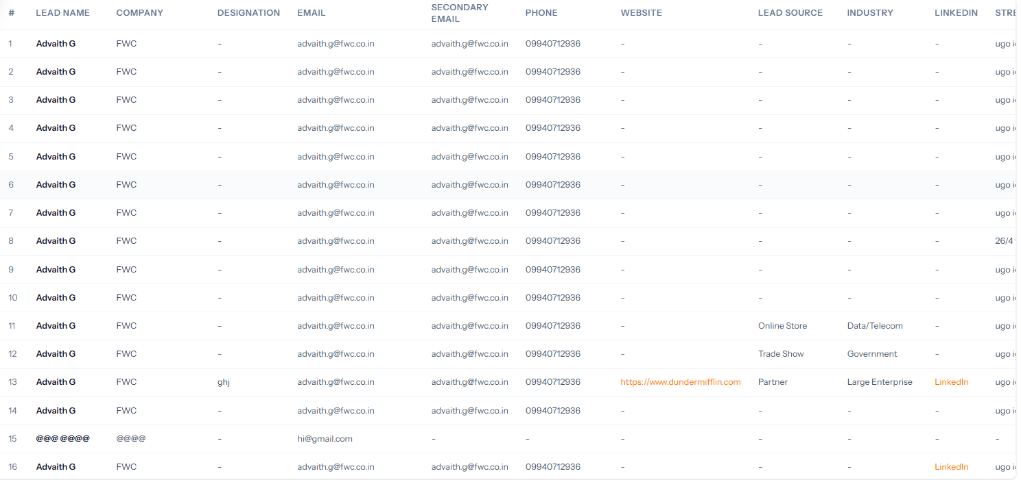
No: AICRM-0038
Result: Pass
No: AICRM-0039
Result: Pass 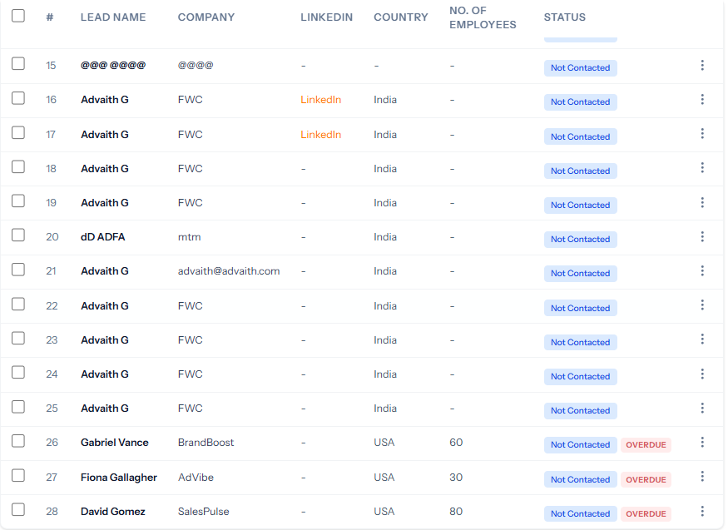
No: AICRM-0040
Result: Pass 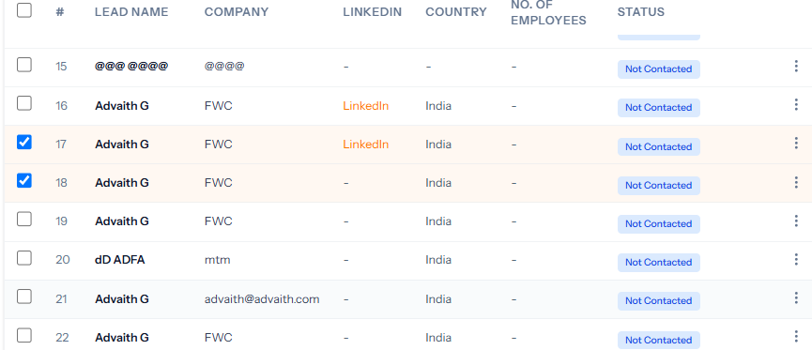
No: AICRM-0041
Result: Pass 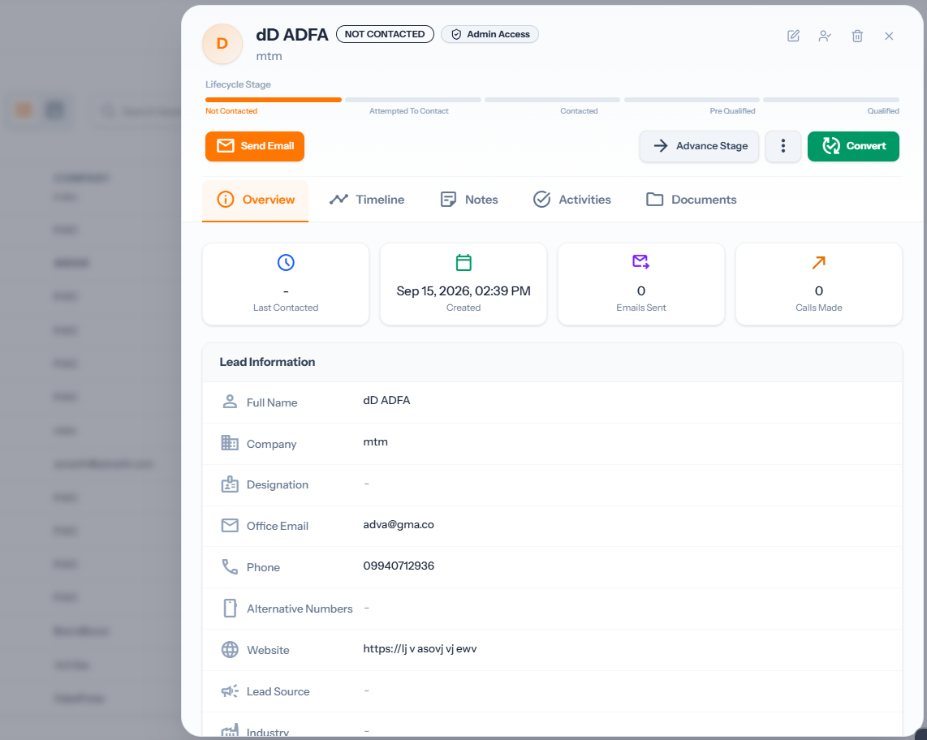
No: AICRM-0042
Result:TestCase not needed
No: AICRM-0043
Result: Pass
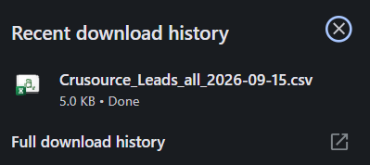
No: AICRM-0044
Result: Pass
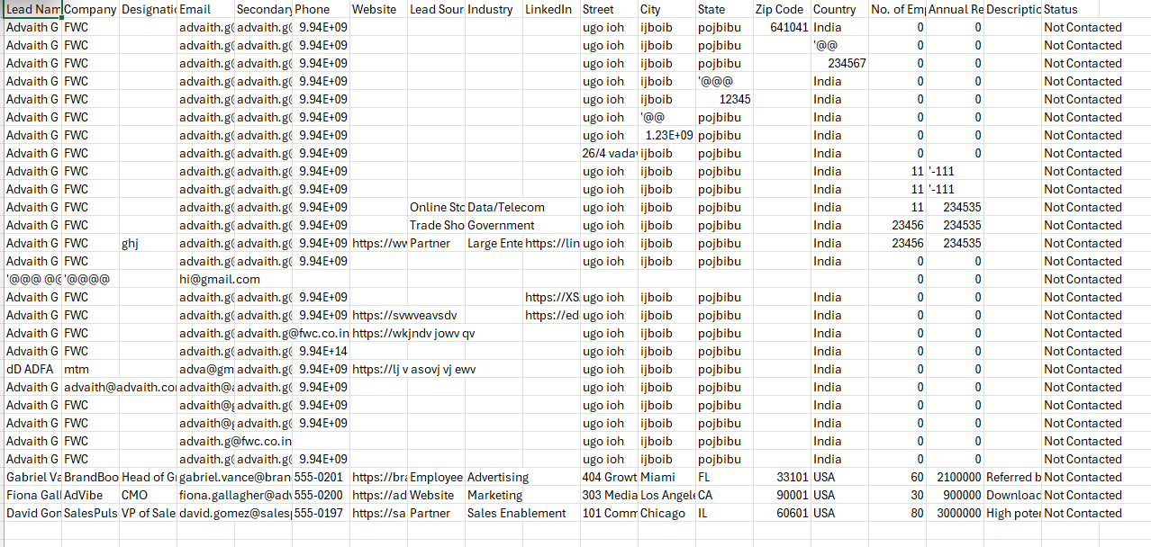
No: AICRM-0045
Result: Pass
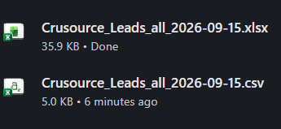
No: AICRM-0046
Result: Pass
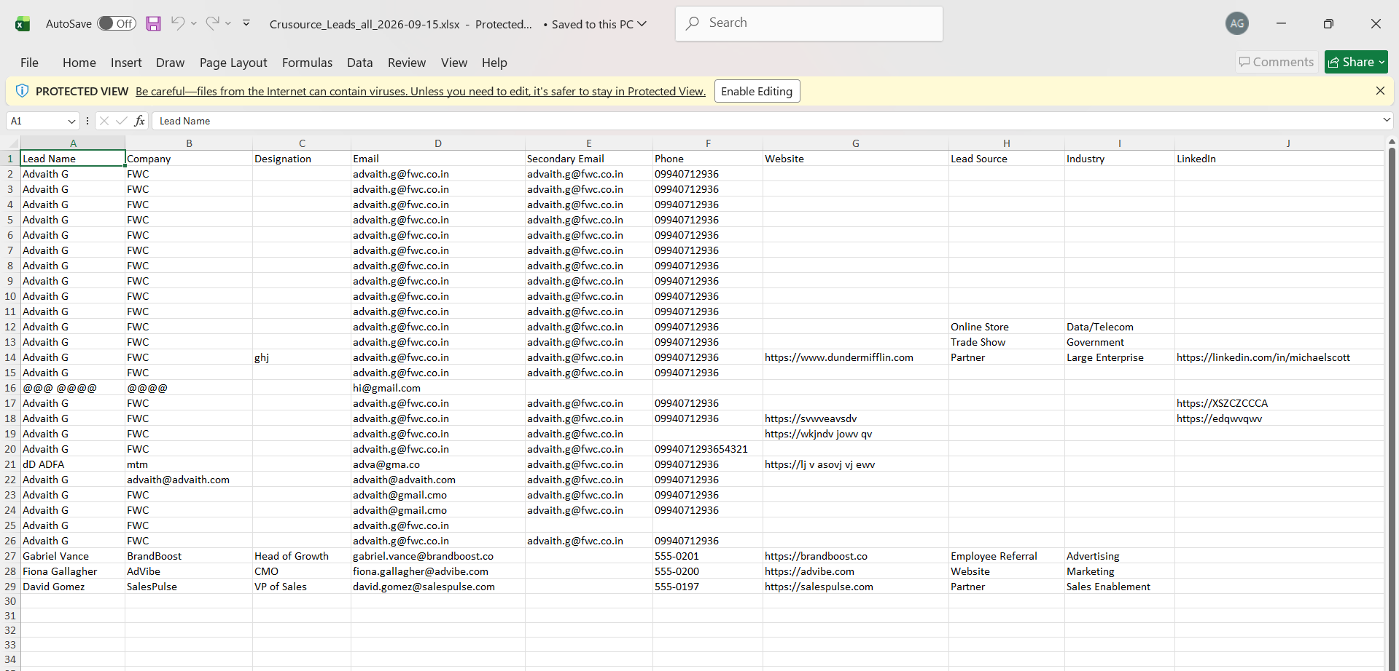
No: AICRM-0047
Result: Pass 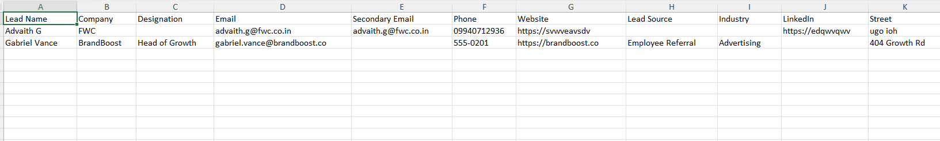
No: AICRM-0048
Result:Testcase not needed

No: AICRM-0049
Result: Pass
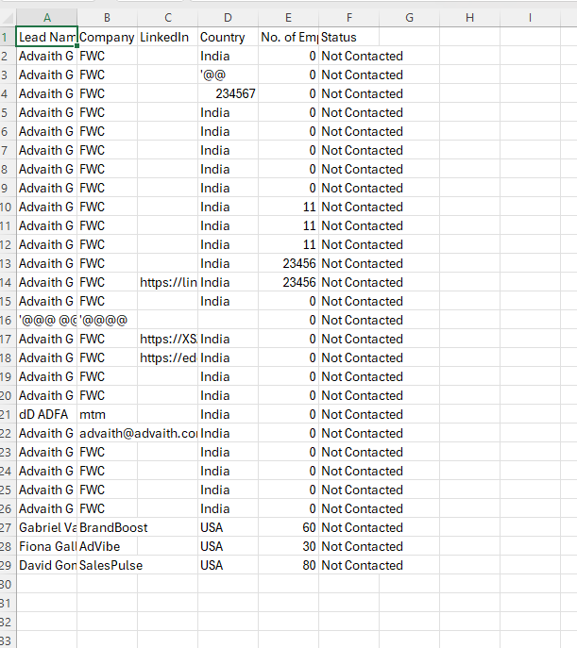
No: AICRM-0050
Result: IMPROVE – Not able to download current view for selected leads
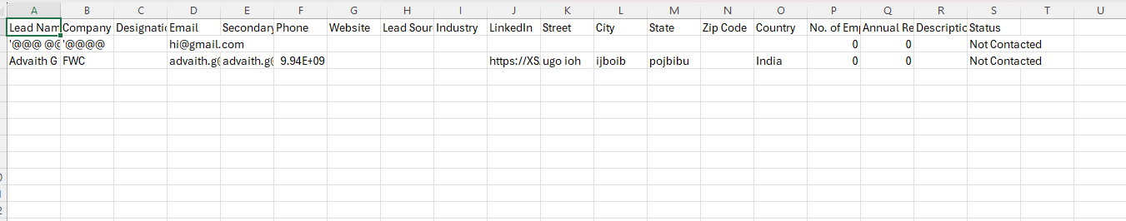
No: AICRM-0051
Result:Test Case already verified
No: AICRM-0052
Result: Test Case already verified
No: AICRM-0053
Result:Test Case Not needed
No: AICRM-0054
Result: Pass 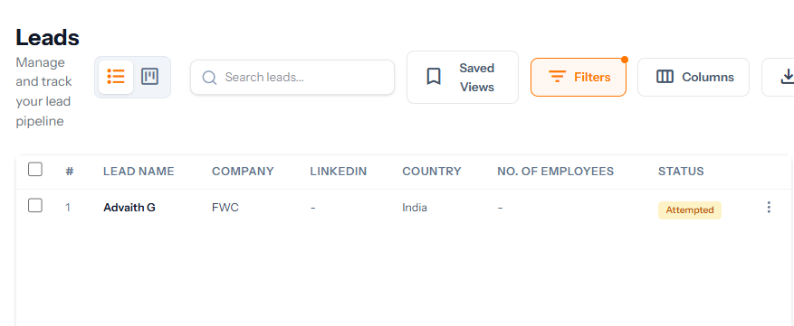
No: AICRM-0055
Result: Pass
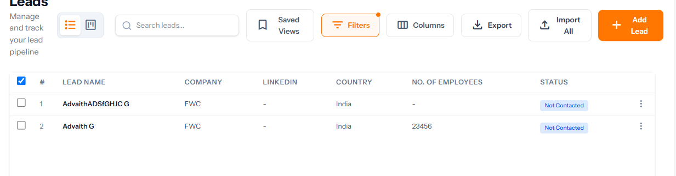
No: AICRM-0056
Result: Pass 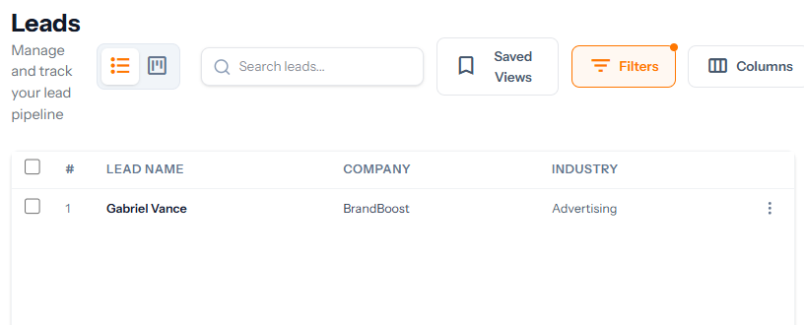
No: AICRM-0057
Result: FAIL - Remove the Entire Section, There is no input for this section
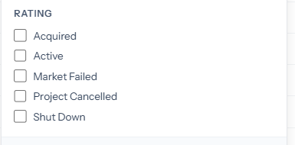
No: AICRM-0058
Result: Pass 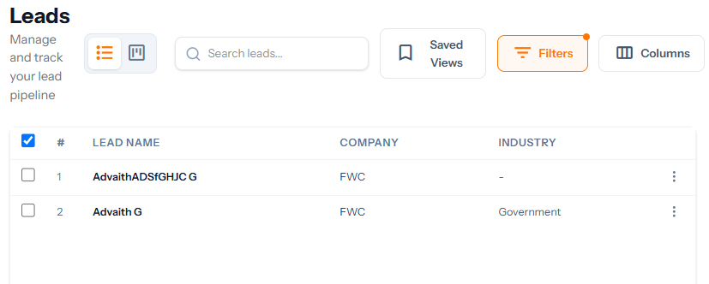
No: AICRM-0059
Result: Pass
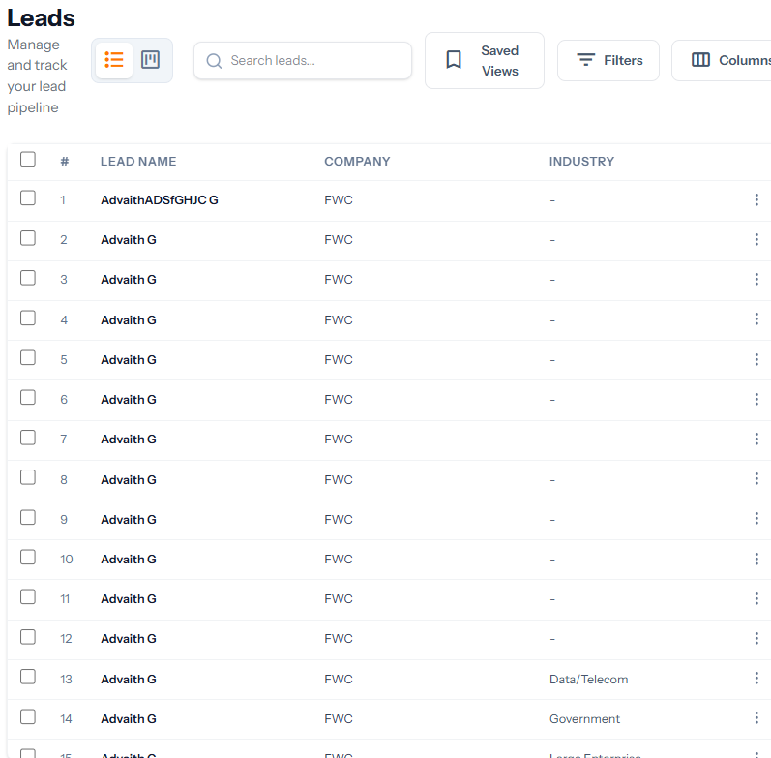
No: AICRM-0060
Result:Test Case not needed
No: AICRM-0061
Result: Pass
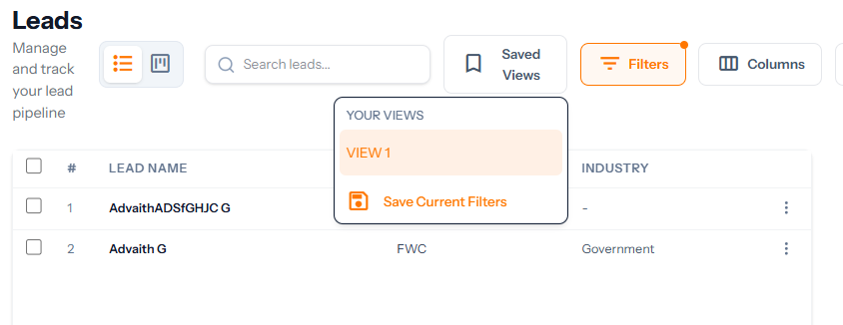
No: AICRM-0062
Result: Pass 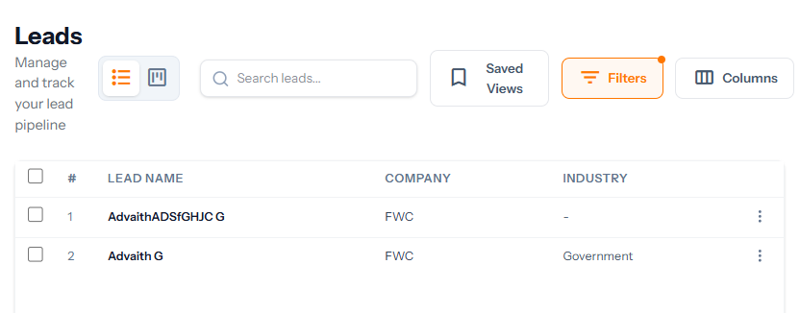
No: AICRM-0063
Result: Pass 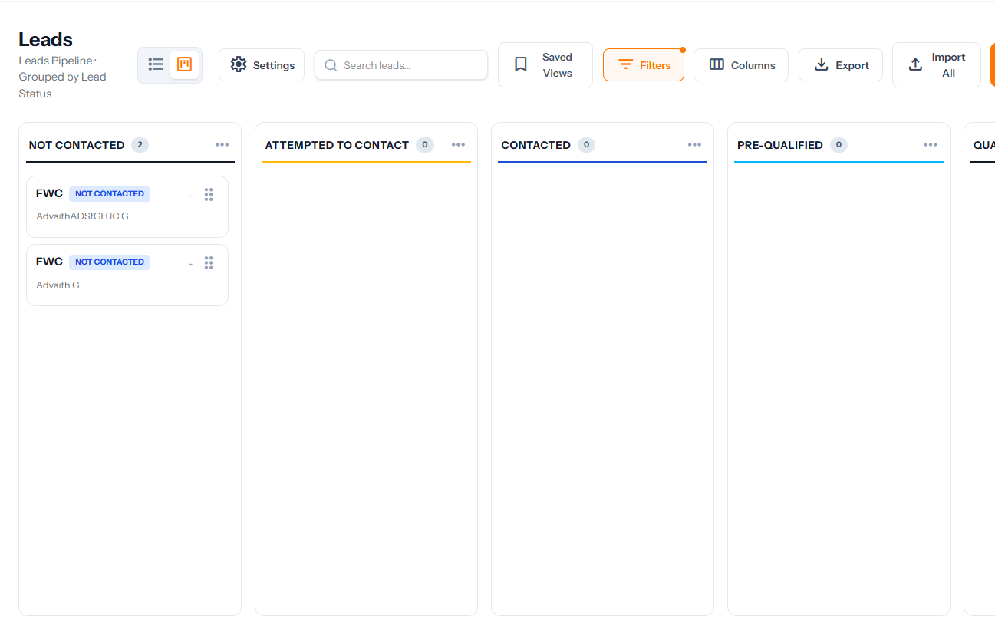
No: AICRM-0064
Result: Pass
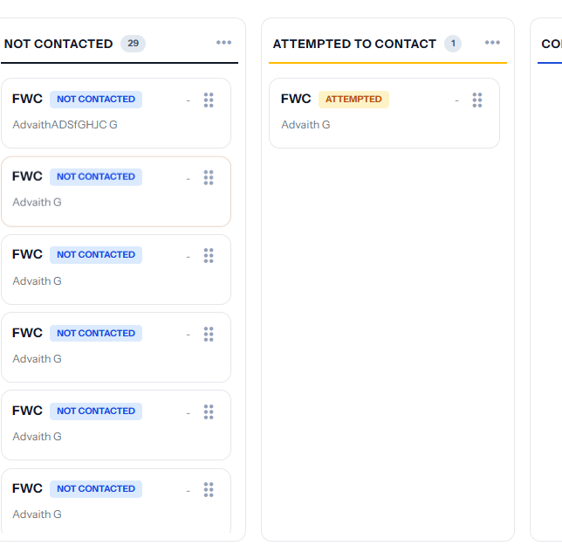
No: AICRM-0065
Result: Pass
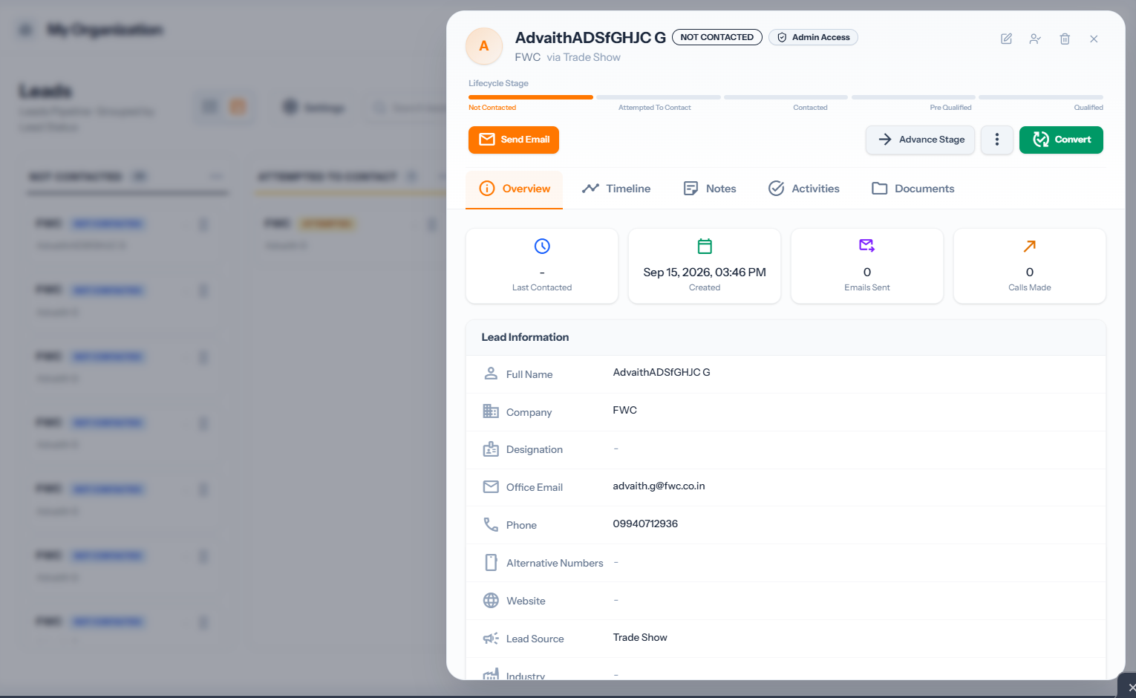
No: AICRM-0066
Result: Pass
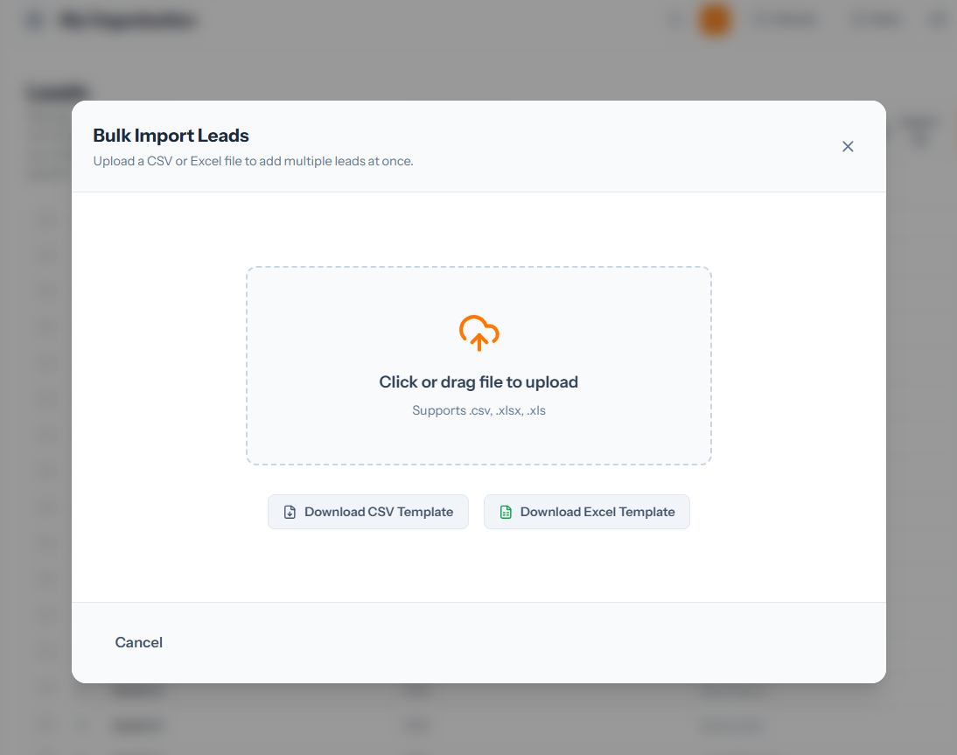
No: AICRM-0067
Result: Pass – Displays only Excel CSV files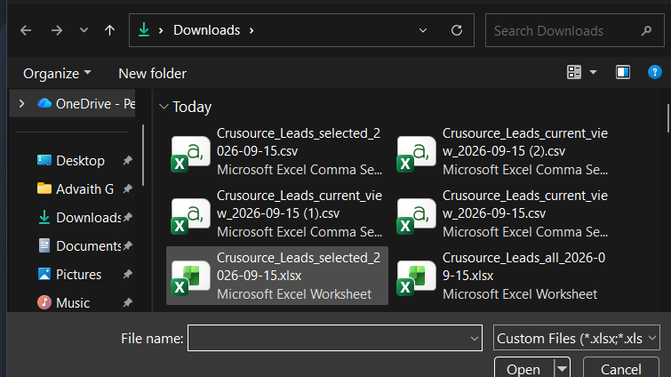
No: AICRM-0068
Result: Pass
No: AICRM-0069
Result: Pass
No: AICRM-0070
Result: Pass 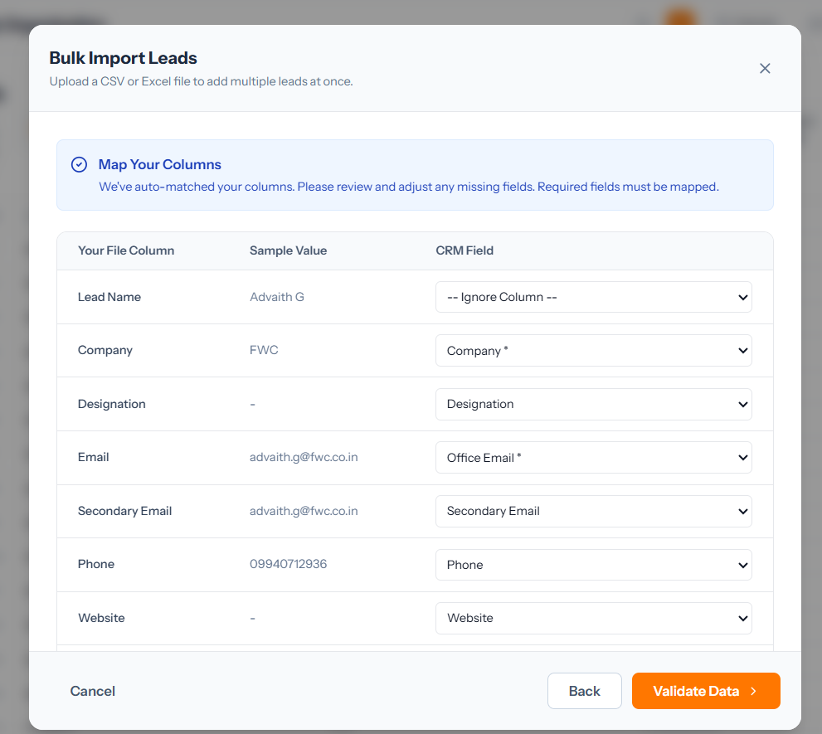
No: AICRM-0071
Result: Pass 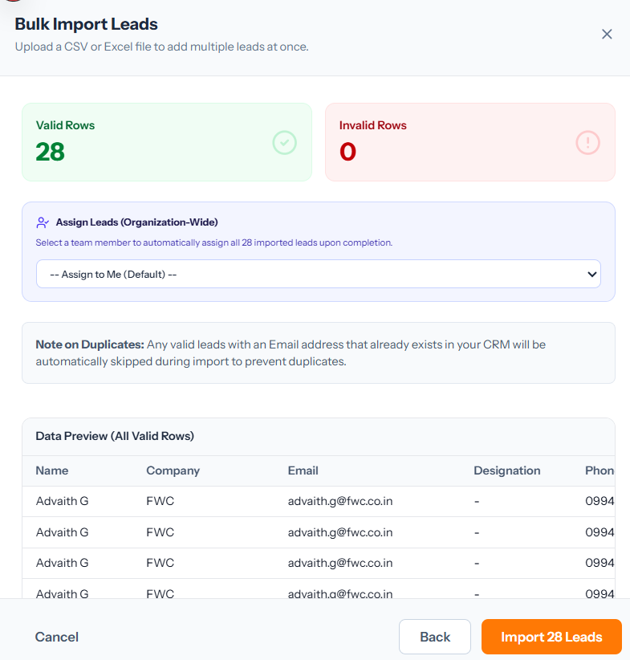
No: AICRM-0072
Result: Pass
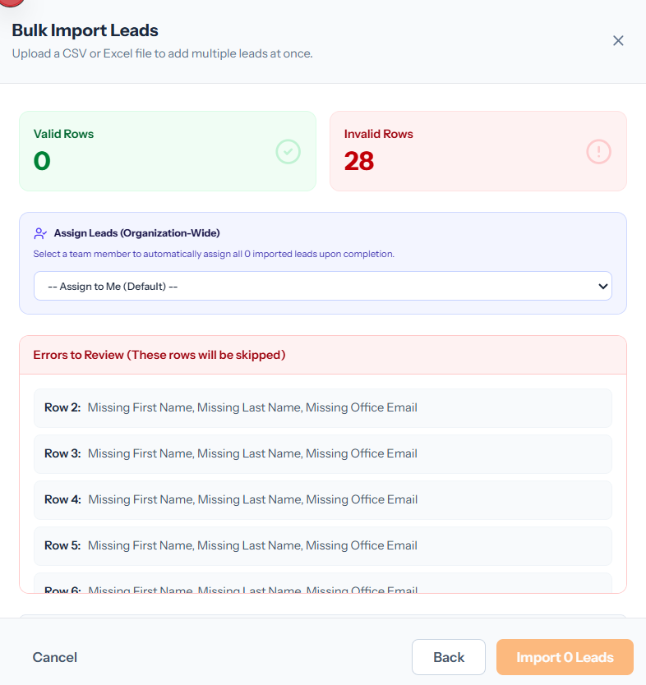
No: AICRM-0073
Result: IMPROVE – Assign to me and account name both are same
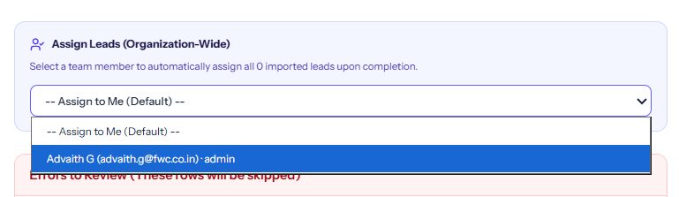
No: AICRM-0074
Result: Pass 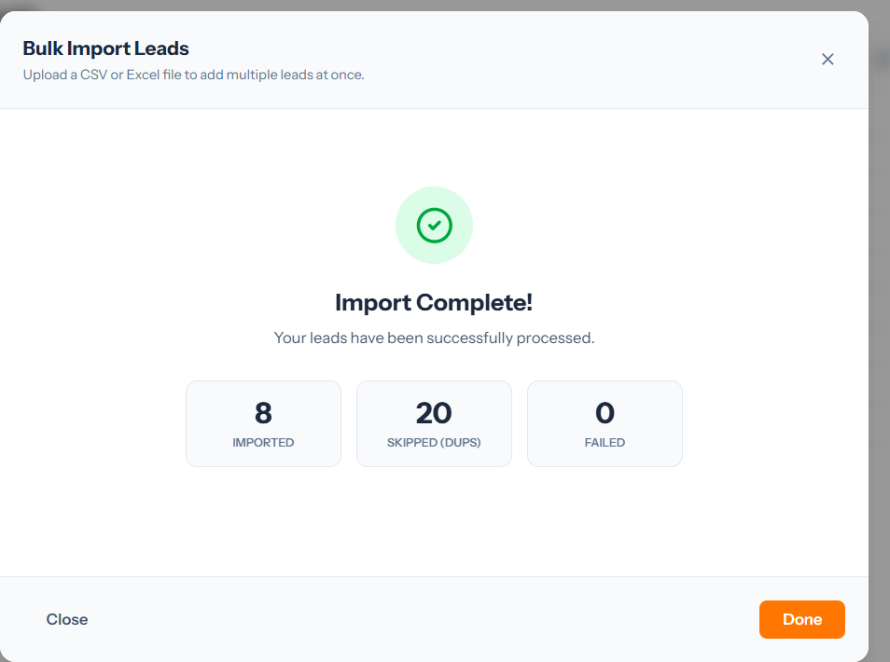
No: AICRM-0075
Result: Pass
No: AICRM-0076
Result: Pass


No: AICRM-0077
Result: Pass
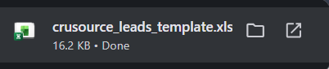
No: AICRM-0078
Result: Testcase Already tested
No: AICRM-0079
Result: Pass 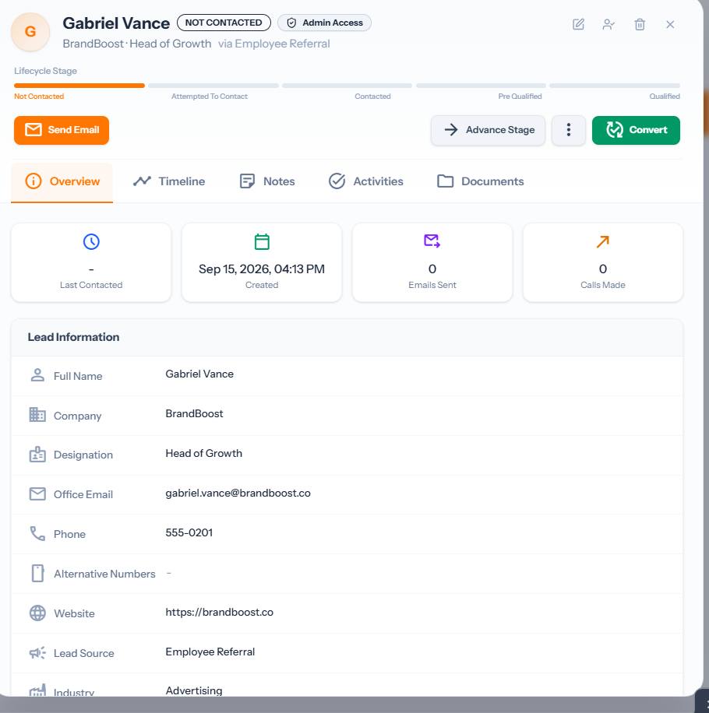
No: AICRM-0080
Result:Testcase not needed
No: AICRM-0081
Result: Pass 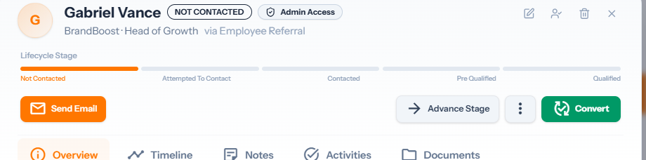
No: AICRM-0082
Result: Pass
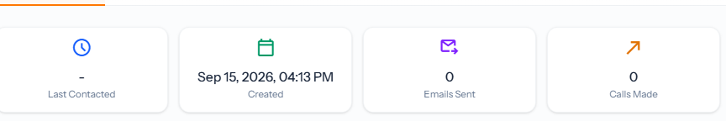
No: AICRM-0083
Result: Pass
